From 29 July we are replacing the current zone boundary system with just one big zone.

Passengers will now be able to travel within a 14-mile radius of their pickup point – meaning access to new destinations. We have also ‘closed the gaps’ so a few parishes in the middle of zones but outside them are now covered. (See attached pic). Limitations mean we’ve not been able to expand to cover those areas which were outside the zones.

Before, if you lived at the edge of a zone there was no Flexibus option to travel into another, which we know for some meant their main services were in the ‘wrong’ zone.

For example, here’s what 14 miles from the middle of Lewes looks like:
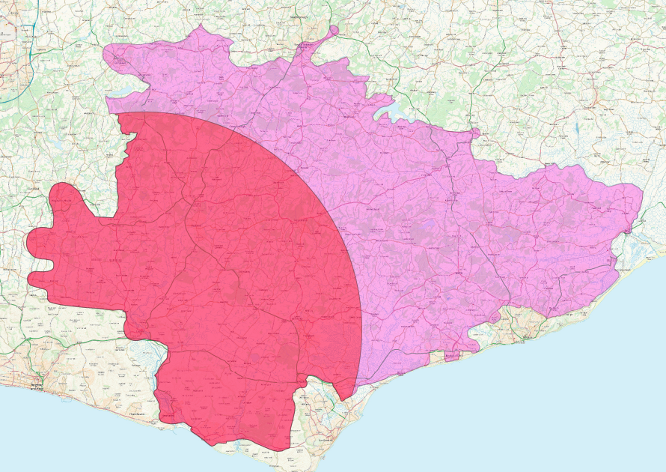

As before, the aim of Flexibus is to complement and support the standard bus networks, and you will not be able to book a ride if there is a bus route going that way. Using any of our buses supports our efforts to increase passenger numbers and show that there is demand for public transport in East Sussex.

Checkout our new travel-checker map to see where Flexibus can take you: https://flexibus.sussex.podaris.com/

How to book remains by calling 01273 078203 (9am to 5pm, Monday to Friday, excluding Bank Holiday) or through the RidePingo app. The app can be used anytime (other than the occasional downtime for maintenance and updates).

Our Flexibus web page will be updated to reflect the changes by the end of the week.

